IICT – Week II – Exercises
Question1:
Bit# | 7 | 6 | 5 | 4 | 3 | 2 | 1 | 0 ANS
Place Value | 2⁷  128 | 2⁶  64 | 2⁵  32 | 2⁴  16 | 2³  8 | 2²  4 | 2¹  2 | 2⁰  1
a. | 0 | 1 | 1 | 1 | 0 | 1 | 0 | 1
b. | 1 | 0 | 1 | 1 | 1 | 0 | 1 | 1
c. | 0 | 1 | 0 | 0 | 0 | 1 | 0 | 0
d. | 1 | 0 | 1 | 0 | 0 | 0 | 0 | 0
e. | 0 | 0 | 0 | 0 | 1 | 1 | 1 | 1

Question2:
If a Byte is assumed to represent a number, as described earlier, then what is the range (minimum and maximum values) of numbers that can be stored in a 8-bit Byte?

Question3:
- The following 24 values represent a message consisting of 24 characters stored in RAM.
- If the message has been written using 8-Bit Extended ASCII codes then decipher the message
87 104 97 84 32 105 83 32 89 111 117 82 32 70 105 82 83 84 32
78 65 77 69 63

Question:4:
- Represent the following integer quantities as sequence of bytes encoded using ASCII characters.
ASCII REPRESENTATION
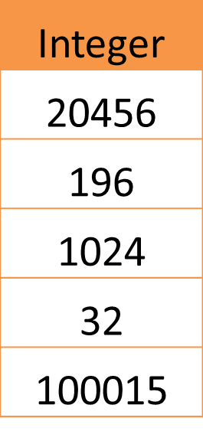

Question5:
- Use 2-Bytes to represent each of the following quantity
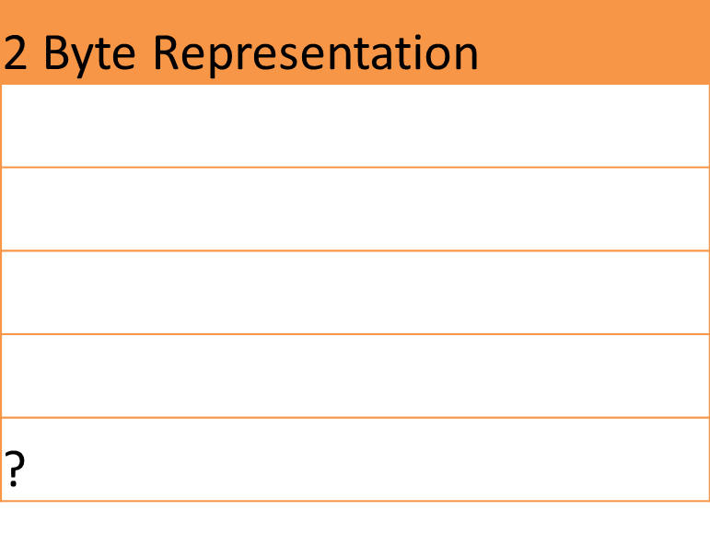
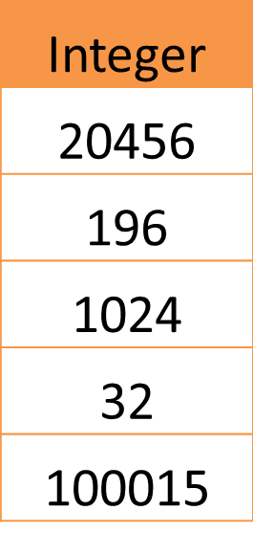

What is the Maximum unsigned integer value that can be represented using 2 Bytes?

Question6:
- Use 4-Bytes to represent each of the following quantity



What is the Maximum unsigned integer value that can be represented using 4 Bytes?
Question7:
- Represent each of the following quantity in 1-bytes using
sign-magnitude method.
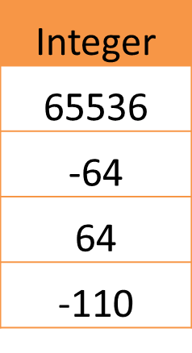
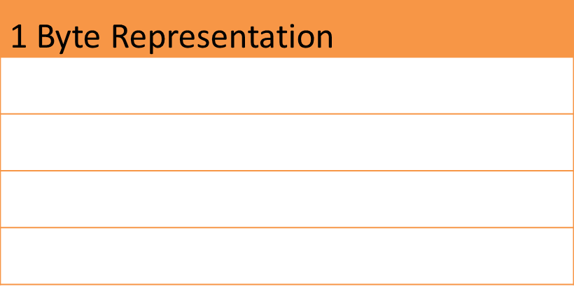

What is the Maximum signed integer value that can be represented using 1 Byte?

Question8:
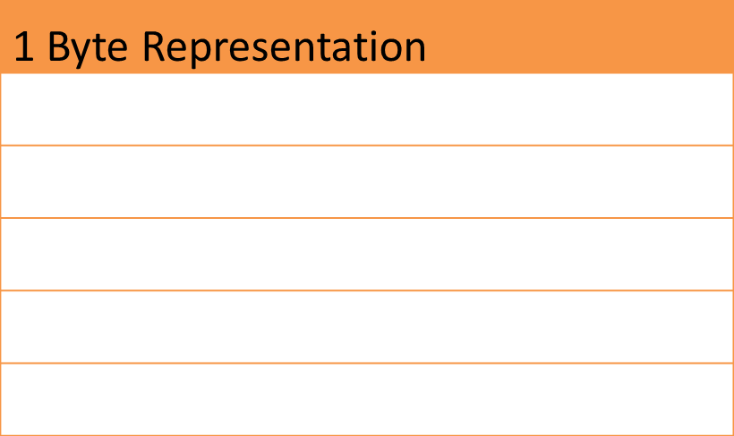
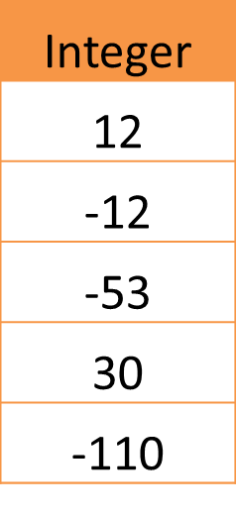
- Represent each of the following quantity in 2’s Complement method.

Question9:

Decimal | Binary | Hexa-  decimal
33
 | 1110101
 |  | 1AF

Question10:
- a. What is the hexadecimal representation of the following number:
  - a) (6742)10
- b. The following numbers are in binary. Convert them to hexadecimal
  - a) 11101110
  - b) 1010001
- c. What is the 2’s Complement of the following numbers.
  - a) +13
  - b) -17
  - c) -55
- d. What is the decimal representation of the following numbers:
  - a) (100111011)2
  - b) (B268)16
- e. Decode the following ASCII message. ASCII Chart is given in the following figure.
01000100 01001111 00100000 01001110 01001111 01010100 00100000 01000011 01001000 01000101 01000001 01010100

